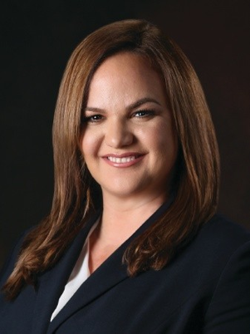Effie D. Silva

SVP, General Counsel & Corporate Secretary, **Fresh Del Monte Produce**

Board Director, **America On Tech**

+1.305.527.5331

[effiesilva@gmail.com](mailto:effiesilva@gmail.com)

[LinkedIn](https://www.linkedin.com/in/effiesilva/)  
 Miami, FL

**With 20+ years of leadership experience driving growth across the agriculture, food, and consumer products industries, Effie delivers value for growth-oriented global companies at the intersection of transformation, international growth and stakeholder engagement.**

Effie D. Silva is a strategic business advisor, and multi- function C-suite leader with experience in publicly traded, privately held, and family controlled global companies in the agriculture, food, manufacturing, ingredients, and consumer packaged goods spaces.

Effie serves as the Senior Vice President, General Counsel and Corporate Secretary for Fresh Del Monte Produce Inc. (NYSE: FDP), an NYSE-traded global food company with $4.5B+ revenue (NYSE: FDP), where she advises the Chief Executive Officer and the board of directors at one of the world’s leading vertically integrated producers, marketers, and distributors of high-quality fresh and fresh-cut fruit and vegetables. The company is also a leading producer and distributor of prepared foods, juices, beverages and snacks. Fresh Del Monte has 40K+ team members globally and markets and distributes its products, which originate from 6,700+ farms worldwide (103K+ acres under production), to retail stores, club stores, convenience stores, wholesalers, distributors and foodservice operators in more than 80+ countries, via an extensive Logistics Operation (freshdelmonte.com/services/) with an international fleet of 13+ vessels (Network Shipping) and U.S. based 200+ trucks/trailer fleet.

As a member of Fresh Del Monte's executive leadership team, Effie is actively engaged in all aspects of the company’s many businesses worldwide, including developing and implementing strategic initiatives through mergers and acquisitions; global expansion planning; governance, risk, and compliance (GRC) and enterprise risk management (ERM); environmental, social and governance (ESG) strategies; brand and community engagement; and compensation programs. Effie has global responsibility for all aspects of the company’s legal affairs, including corporate governance, mergers and acquisitions, commercial matters, intellectual property, compliance and ethics, internal investigations, cybersecurity, litigation, as well as professionals responsible for global government affairs, regulatory affairs, global business conduct and the company’s global health, safety, environmental and sustainability efforts.

In the 20 years preceding her joining the senior executive leadership team at Fresh Del Monte, Effie was an executive at Cargill and Tyson Foods, and partner with an Am Law 100 law firms where she regularly advised corporate leaders and Boards of Directors of multinational companies on corporate governance, regulatory compliance and investigations, M&A, complex business litigation and international arbitration matters.

In addition to her corporate roles, Effie also serves as an independent director on the National Board for America On Tech, an award-winning nonprofit that serves as an early pipeline technology talent accelerator that prepares the next generation of leaders by creating pathways into degrees and careers in technology.