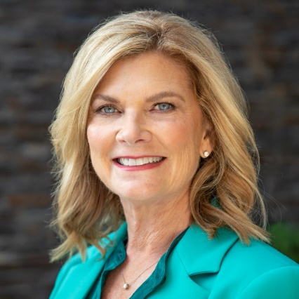**Lisa M. Davis**

San Diego, CA | 202-557-5986

Email: [mako254@verizon.net](mailto:mako254@verizon.net) | LinkedIn: <https://www.linkedin.com/in/mako254/>

**Visionary Board Leader Driving Digital Transformation, Cybersecurity, and AI Innovation| Global Transformational CIO and Business Leader of a $9B** **Global P&L**

Lisa Davis is an accomplished board member and global technology executive with a proven track record of driving enterprise modernization, optimizing governance strategies, and fostering innovation in AI, cybersecurity, and digital transformation. With over 30 years of experience across healthcare, high-tech, federal government, and academia, she has successfully led $28B in digital transformation initiatives and turned around a $9B global business.

**CURRENT BOARDS**

**Movius (2023–Present) Board Director | Nom/Gov Committee Member**

AI-powered, global provider of secure mobile unified communications ($37M revenue)

* Led board oversight on AI and cybersecurity strategy, strengthening compliance and customer trust by XXX%
* Supported executive leadership in refining go-to-market strategies and expansion resulting in XXX

**TriWest Healthcare Alliance (2023–2025) Board Director**

Healthcare services for military and Veteran communities ($1.4B revenue).

* Provided governance and oversight on operational strategies, enhancing service efficiency and provider partnerships improving XXX by XXX
* Contributed to financial and risk management discussions to improve long-term sustainability resulting in XXX

**Blue Shield of California Foundation (2020–2025) Trustee | Audit Committee Member**

Nonprofit focused on health equity ($50M budget).

* Strengthened financial oversight, ensuring sustainability and maximizing philanthropic impact.
* Championed digital innovation strategies to improve healthcare accessibility and operational efficiencies.

**PREVIOUS BOARDS**

* **United States Marshals Survivors Benefit Fund (2019–2020)** – Led initiatives enhancing support for families of fallen officers.
* **National Center for Missing and Exploited Children (2017–2018)** – Advised on technology and cybersecurity strategies to strengthen child protection efforts.
* **Mirantis (2016–2018)** – Oversaw cloud innovation and investment strategy for enterprise adoption.
* **National Academy Foundation (2014–2015)** – Supported IT education and workforce pipeline initiatives.
* **Xerox Customer Advisory Council (2014–2015)** – Provided strategic insight into enterprise digital transformation.

**INDUSTRY RECOGNITION & THOUGHT LEADERSHIP**

* **Awards:** 2023 National ORBIE Healthcare CIO of the Year, 2022 Forbes CIO Next List, 2020 CIO Hall of Fame, FutureEdge 50 Award.
* **Speaking Engagements:** Featured at Forbes, Evanta CIO Summits, and AI & digital transformation forums.
* **Advisory Boards:** Salesforce CIO Advisory Board, Google CIO Advisory Board, Harrisburg University Cybersecurity Advisory Board.

**EXECUTIVE LEADERSHIP EXPERIENCE**

**Blue Shield of California (2020–2025)**

**Executive Vice President & Chief Information Officer**

* Led enterprise-wide digital transformation for a $28B nonprofit health plan serving 6M+ members.
* Spearheaded AI and cloud-first technology strategies, increasing member digital engagement and operational efficiencies.
* Architected California’s Vaccine Task Force technology strategy, ensuring 43M vaccine doses were administered equitably.
* Led development of a state-of-the-art care management system, improving quality of care for 18K+ patients in its first year.

**Intel Corporation (2015–2020)**

**Vice President & General Manager, Enterprise & Government Data Center Group**

* Reversed a seven-year decline of Intel’s $9B global data center business, restoring profitability.
* Developed AI and cloud adoption strategies for Fortune 100 enterprises and government agencies.
* Led cross-enterprise IT teams overseeing supply chain, HR, finance, and corporate operations.

**Georgetown University (2012–2015)**

**Vice President & Chief Information Officer**

* Led a digital transformation, modernizing infrastructure and enterprise applications to enhance competitiveness.
* Earned CIO 100 Award for innovative cost-saving technology strategies.

**Federal Government (1999–2012)**

**Senior Executive Service (SES) | CIO, U.S. Marshals Service | CIO, Counterintelligence Field Activity (DoD)**

* Directed global technology transformations and cybersecurity initiatives across classified networks.
* Led mission-critical IT operations for national security, law enforcement, and intelligence agencies.

**EDUCATION & CERTIFICATIONS**

* M.S., Human Resources Management, Golden Gate University
* B.S., Computer Engineering, Syracuse University
* Stanford University Graduate School of Business – Executive Accelerator
* CISSP (Certified Information Systems Security Professional) – Inactive
* U.S. Security Clearance (TS/SCI) – Inactive

**PERSONAL & PHILANTHROPY**

Lisa is a health and wellness enthusiast, an avid outdoor adventurer, and a dedicated mentor for women in technology. She is committed to advancing opportunities for women in STEM and supports female tech entrepreneurs.