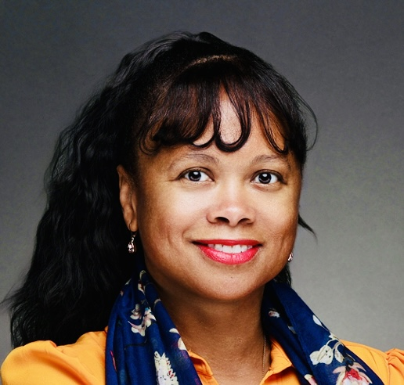
SELENA S. CUFFE, MBA, CM
selena@stanfordalumni.org | 773.531.9555
Global Growth Accelerator
Commercialization, Transformation
BOARD EXPERIENCE
Federal Reserve Bank of San Francisco Los Angeles Branch Director
One Power Company
Independent Board Director
Harvard Business School
Advisory Board (HBS WSA) Chair, Nom. & Gov. Santa Clara University
Black Corporate Board Readiness Program (Cohort 8)

Selena Cuffe is an award-winning executive recognized for building go-to-market strategies and accelerating revenue for global enterprises. She has 20 years of senior leadership experience, and her governance experience includes chairing multiple board committees. Selena builds and advises high performing teams and cultures, and sustainably grows businesses through innovation, strategic restructure, and acquisition.
As President of SodexoMagic, a $650M, 6,000 person firm owned by Earvin "Magic" Johnson and Sodexo, Inc., serving corporations, governments, K-12 schools, and universities, Selena grew sales by 35% and closed the two largest deals for Sodexo North America in 2021, totaling more than $300M over three years. Currently she is the Chief Growth Officer of Blackstone Consulting, Inc. (BCI), a $900+ million, 10,000-person international services firm and minority business enterprise (MBE).
Selena Cuffe has a successful track record of growing global organizations. She is co-founder of Heritage Link Brands for which she served as President & CEO, opening commercial markets for black South African wine producers globally. She has successfully galvanized large field organizations, while turning around underperforming business units. Additionally, she has created private labels, channel partnerships, and M&A initiatives, including the acquisition of Byte Foods.
Her P&L management experience has ignited operational excellence through innovation, commercializing ESG initiatives, brand and market repositioning, and supply chain diversification. Her international experience includes working in over 40 countries, and she is a life member of the Council on Foreign Relations.
An industry thought leader, Selena serves as a Director for the Federal Reserve Bank of San Francisco and the One Power Company, a national leader in on-site energy solutions for large industrial clients.
She is a Les Batisseurs de l'Économie Africaine (Africa Economy Builders) awardee and UCLA Anderson School of Management Riordan Programs Distinguished Alumni and Hall of Fame recipient. Selena serves on the audit committee for the One Power Company. She chairs the Nominating & Governance committee for the Harvard Business School Women Students Alumnae Advisory Board and is incoming Chair of the Stanford University Bing Overseas Studies Programs (BOSP) Advisory Council.
Selena earned her Bachelor of Arts in International Relations, with minors in Spanish & Portuguese, from Stanford University and a Master of Science in Business Administration, with honors, from the Harvard Business School. She is a Diamond Life member of Delta Sigma Theta Sorority, Inc., mother member of Jack and Jill of America, Los Angeles, certified mediator, and an advocate for foster care youth. Selena is married with three children and makes her home in View Park-Windsor Hills, California.

