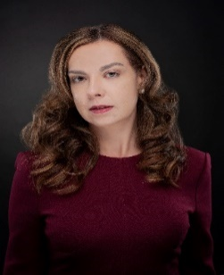 | Veronica (Hincapie) Foley, Chief Legal & Compliance Officer  Veronica Foley is an experienced executive, and a strategic business partner who effectively anticipates challenges and thoughtfully influences change and evolution. Over the years, she has advised C-level and board executives worldwide during transformational periods across various dynamic industries, bringing a unique blend of board leadership skills encompassing governance, compliance, ESG, shareholder activism, M&A, strategic planning, and risk oversight.
Veronica is the Chief Legal and Compliance Officer at Precision Drilling Corporation (NYSE: PDS). In her role, Veronica focuses on ways to enhance the management of legal risk and the operation of the legal department and serves as a member of the company’s enterprise risk management committee. Her team is located across multiple markets and operates with a global outlook, providing legal expertise and advice across various subject matter and regulatory areas, and leading the support for many strategic and cross-functional initiatives.
Before joining Precision, Veronica spent over seven years as an attorney with Norton Rose Fulbright, LLP, providing legal advice to prominent corporations and financial institutions.
Veronica is from Colombia; she is a native Spanish speaker and is also proficient in French and Portuguese. She has lived in Australia, Spain, Colombia, and France, the foundation for her own strategic adaptability. Her international background and experience working with multinational companies give her a deep understanding of the challenges and opportunities of conducting business across borders.
Veronica holds a Bachelor of Arts degree in Psychology and French from Baylor University and a Doctor of Jurisprudence degree cum laude from South Texas College of Law. She currently serves on the Board and as chair of the Nom/Gov Committee of Spindletop Charities, Inc., and the Institute of Hispanic Culture of Houston and has served on other non-profit boards of various educational and professional institutions, including the Houston Bar Foundation - the charitable arm of the Houston Bar, and Girls Inc. of Greater Houston.

