**Nancy Casey**

+1 646.322.1229 ▪ nancyparkcasey@gmail.com

<https://www.linkedin.com/in/nancy-casey-3723791/>

***AI and SaaS Technology Executive, Board Member***

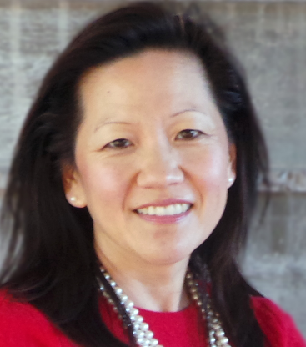Nancy Casey is an innovative, global technology executive and Board Member with over 20 years of experience in growing and leading successful businesses. Nancy specializes in AI and enterprise cloud software, industry strategy and sales within healthcare, consumer and supply chain industries. She serves on two Boards. She has worked in executive roles, where she managed SaaS business units ranging from $200M - $2B annual revenues. She developed businesses to over 3x revenues. Nancy also founded two profitable startups. She is an Advisor and Investor in multiple businesses.

**Professional Experience**

Nancy is a former Group Vice President, Healthcare and Consumer Industries Leader at Oracle Corporation. She developed new $1B+ business opportunities focused on AI-driven, consumer-centric experiences within the healthcare, consumer and supply chain industries. Nancy was also Group Vice President of the Strategic Clients Group where she managed over $2B industry software sales and grew her business significantly in one year with over 3x pipeline opportunities.

Prior to Oracle, Nancy worked as an executive for over a decade at SAP, where she was the Global Head of Industry Cloud Strategy managing 20 industries and over $1.5B new SaaS P&L. She launched new global SaaS industry cloud solutions to market to drive over 3x revenue targets. She was also the Global Vice President and General Manager of the Retail and Consumer Goods Business Unit, focused on driving new solutions and sales within merchandising, digital marketing, and supply chain operations. She managed over $1B SaaS software license sales and consulting services. Nancy has held management positions at Deloitte Consulting where she led enterprise-level technology implementations. She founded a healthcare mobile inventory software startup which was sold to a private investment group, and founded an investment group focused on high-growth assets and startups.

**Boards and Advisory Roles**

Nancy currently serves as a Board Member of the National Wharton and Penn Alumni Organization. She also is an Advisory Board Member of OpenClaims, which is an AI software company for medical data management businesses. She works as an Advisor to the National Consumer Federation and Association of National Advertisers. She is an Advisor and Investor in multiple software startups, and is a Member of Chief and the Athena Women’s Executive Network.

**Certifications and Degrees**

Nancy has an MBA from The Wharton School at the University of Pennsylvania, and received her BA in Economics at Cornell University.