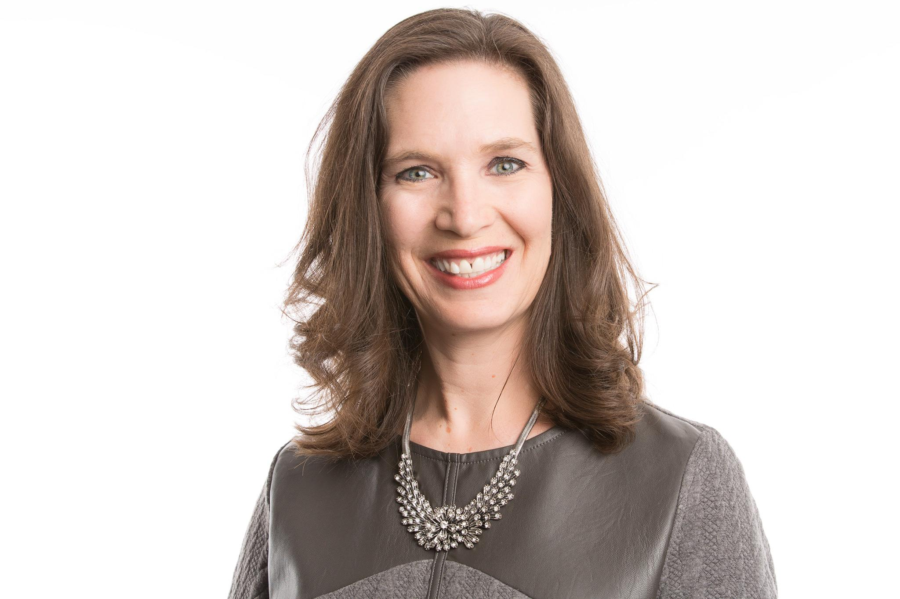

**Joanna Zucker**

[zuckerjp1@gmail.com](mailto:zuckerjp1@gmail.com)

CEO | P&L | Business Growth Expert

CMO | Digital Transformation | Innovation

Global | M&A | Compensation

VALUE ADDED BOARD EXPERIENCE

* 25 years experience owning and managing a P&L across a range of industries; CPG, Aesthetics/Professional skincare and Retail services. Well versed in Working capital and Cash management.
* Strategic leadership of global brands including Innovation/New products, Marketing Plans and Investment, Market expansion, E-Commerce and Business Models
* Disciplined Operator who has managed a variety of Supply chains and Cost of Goods including Contract Manufacturers, Distribution, Warehousing and Procurement
* Well versed in Compensation, Organization Design and Training & Development; from executive to entry level, salaried to hourly, and incentive plans
* Digitally transformed businesses and tech stacks; DTC and B2B platforms, Learning Management Systems (LMS), Customer Database and Journeys, Digital marketing capabilities (AI skin coach, Consumer CRM, SEO, Loyalty, AI PDP pages), Sales CRM, Call Center software
* Led integration of PCA skin, EltaMD and Filorga into Colgate including ERP, IT infrastructure, Financial and People systems, and the creation of new US legal entity CP Skin Health Group.
* Lived and worked in Brussels, Belgium, leading business development and expansion for P&G’s Surface Care category
* Published author (2008) of *Millennium Mom: tips to help you go from a working woman to a working mom*; monthly *Millennium Mom* segment on Cincinnati Fox 19 for busy moms (Dec ’08 through Oct ’13)

PROFESSIONAL CAREER CHRONOLOGY

**CP Skin Health U.S. (subsidiary of Colgate-Palmolive), Scottsdale, AZ *May 2019-Present***

***CEO, EltaMD, PCA Skin, Filorga brands***

*Own P&L, strategy and operations (>$275M in sales, $50M+ Profit, 240+ FTE, annual growth 15%+)*

* Tripled Topline sales and quadrupled NPAT during tenure
* Scaled the company from PE backed to Enterprise, from independent to portfolio of brands
* Digitally transformed the company internally (new ERP, CRM, reporting, AI tools) and externally (DTC platforms) across all software platforms and vendors
* Integrated three brands into new LLC including Data & Systems unification, new company Mission & Values, new Warehouse and Distribution center, new Corporate HQ, Hiring of over 90 new employees
* EltaMD was recognized as WWD “Breakthrough Brand” in ‘22, FAST Company award winner ‘22 & ‘23

**PETSMART, Phoenix, Arizona *July 2015 – October 2018***

***Vice President Pet Services Division (Grooming, Boarding, Day Camp, Training)****Owned P&L of $900M business, $275M in margin, 22,000 store associates, 190 person call center, 90 field leaders and 35 corporate team.*

* Responsible for the Operations across 1,600+ Grooming Salons, Training centers and 200 Pet Hotels, as well as Product innovation, Compensation, Training & Development (including Grooming academy), Pricing, Promotions and Labor models
* Developed strategy and secured funding and partners for new Digital platform to run operations; Online booking and payment, Data management system for Pet parent and Pet information, holistic service journeys including photo sharing, service tracking, text alerts when pet was ready and digitization of all record keeping.

**PROCTER & GAMBLE, Cincinnati, OH & Brussels, Belgium**

***VP Global Brand Leader, Personal Cleansing – Safeguard, Olay, Camay and Ivory April 2014 –June 2015***

*Chief Brand Officer of Olay, Safeguard, Ivory and Camay portfolio of $1.4B sales and $200M profit*

* Divested Camay brand to Unilever, December 2014, including lead commercial member of deal team

***VP Marketing, Global Beauty Sector, Special Assignment Sept 2013 - March 2014***

* *Created new Branding Organizational Design for $20B beauty business for Beauty President, Deb Henretta.*

***VP Marketing, Global Beauty & Grooming New Business Creation June 2010* - *May 2013***

*Charged with creating and qualifying the entire innovation portfolio Beauty & Grooming Business Sector, with Sales potential of $3B+*

***Marketing Director, Global Hair Care Front End of Innovation June 2006 - May 2010***

*Created significant global business growth through Front End Innovation (Upstream Innovation) for the $12.5B business portfolio (Pantene, Head & Shoulders, Herbal Essence, Clairol, Wella)*

***Brand Manager, Bounce N. America August 2003 - September 2005***

* $350M brand, owned P&L, new product innovation, Marketing plan, Agency partnerships, Media plan

***Brand Manager, Global Swiffer and Mr. Clean, Brussels, Belgium September 2000 - September 2002***

* Led expansion of Swiffer including licensing of Dusters tech and 5 year strategic growth plan to achieve $1B in sales

BOARD EXPERIENCE

**Curie Co**, Raleigh, NC BioTech Start-Up, 2023-Present

* Board Member (paid) and Advisor to CEO/Founder
* Venture backed, female-founder start-up

**St. Mary’s Food Bank**, Phoenix, AZ, 2022-Present

* Board Member, Audit committee, Mission & Means committee
* NGO

**Colgate Palmolive**, NY, NY, 2019-Present

* Frequently presented to Board of Directors

**PetSmart**, Phoenix, AZ, 2015-2018

* Frequently presented to Private Equity (BC Partners) Board of Directors

**Whispering Hope Ranch Foundation,** Scottsdale, AZ, 2018-Present

* Board member, Chair Governance Committee
* NGO

EDUCATION

* M.B.A. University of Michigan (with High Distinction), international experience in Tokyo, Japan
* B. S. in Marketing, University of Scranton (Summa Cum Laude), study abroad Melbourne, Australia