Brenda Boehm
Email: brenda.boehm@gmail.com
Linkedin.com/in/brendaboehm
PH: (978)289-3752
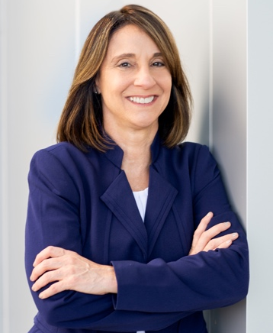

Biography:

Brenda is a highly accomplished C-level and board executive. She seamlessly blends her business acumen with extensive expertise in advanced next-generation networks, security, big data artificial intelligence (AI) analytics, edge computing, and Internet of Things (IoT) technologies to provide advisory leadership for emerging technology companies. Her strategic vision, technical depth, industry knowledge, and board governance skills have left an indelible mark on the companies she has served.

Key Points:
- Diverse Leadership Roles: Brenda’s journey spans both executive and board leadership positions. She has steered innovation-focused technology companies across the spectrum.
- Market Visionary: Brenda’s multifaceted experiences have equipped her with a unique perspective. She recognizes industry disruptions, harnesses change for innovation, and develops strategies for global market expansion.
- Secure Operational Best Practices: Brenda’s commitment to secure operational excellence is unwavering. Her insights ensure that organizations leverage today’s technologies effectively, resulting in new products, operational efficiencies, and expanded global reach.
- Current Endeavors: As a member of the governance board at Underline Networks, Brenda provides strategic guidance and corporate oversight. Her mission there? To transform city fiber access landscapes.
Brenda’s legacy lies in her ability to bridge the gap between cutting-edge technology and strategic business outcomes. Her impact reverberates across the corporate landscape, driving transformation and shaping the future of tech-driven enterprises.

Academic Background:

Executive Business Strategy for Artificial Intelligence
MIT Sloan, Boston, MA
Carnegie Mellon Chief Information Security Officer Certificate
Carnegie Mellon, Pittsburgh, PA
Stanford Advanced Computer Security Certificate
Stanford University, Palo Alto, CA
Stanford Executive Program
Stanford University, Palo Alto, CA
Master of Science in Telecommunications Management
Southern Methodist University, Dallas, TX
Bachelor of Business Administration – Computer Information Systems
Northeast Louisiana University, Monroe, LA

